Assessment Tool 1
CO4_AT2_Industry Problem Solving

Course: Computer Vision Name: K.Teja Sri
Course Code: ITA0506 Register No:192525249

1. Autonomous Vehicle Vision System Selection
An automobile company is developing an autonomous vehicle detection system that must
operate under the following conditions:
• If accuracy &lt; 90% → system fails
• If latency &gt; 70 ms → unacceptable
• The vehicle supports moderate computational resources
Methods available:
• Viola-Jones: 82% accuracy, 30 ms latency, low computation
• YOLO: 93% accuracy, 60 ms latency, moderate computation
• Deep Learning: 97% accuracy, 90 ms latency, high computation
Task:
Compare the three methods and evaluate which method satisfies all the constraints. Justify your decision using logical reasoning based on accuracy, latency, and computational requirements.

Method | Accuracy | Latency | Computation | Meets Accuracy ≥ 90%? | Meets Latency ≤ 70 ms?
Viola-Jones | 82% | 30 ms | Low | ❌ No | ✅ Yes
YOLO | 93% | 60 ms | Moderate | ✅ Yes | ✅ Yes
Deep Learning | 97% | 90 ms | High | ✅ Yes | ❌ No

Logical evaluation:

- Viola-Jones: Accuracy is 82%, which is below 90%. Therefore, the system fails.
- YOLO: Accuracy is 93% (≥90%), latency is 60 ms (≤70 ms), and it requires moderate computation. Therefore, it satisfies all constraints.
- Deep Learning: Accuracy is excellent at 97%, but latency is 90 ms, which exceeds the 70 ms limits. It also requires high computation, which is unsuitable for the given resources.

Decision:
YOLO is the best choice because it satisfies the accuracy, latency, and computational-resource requirements.

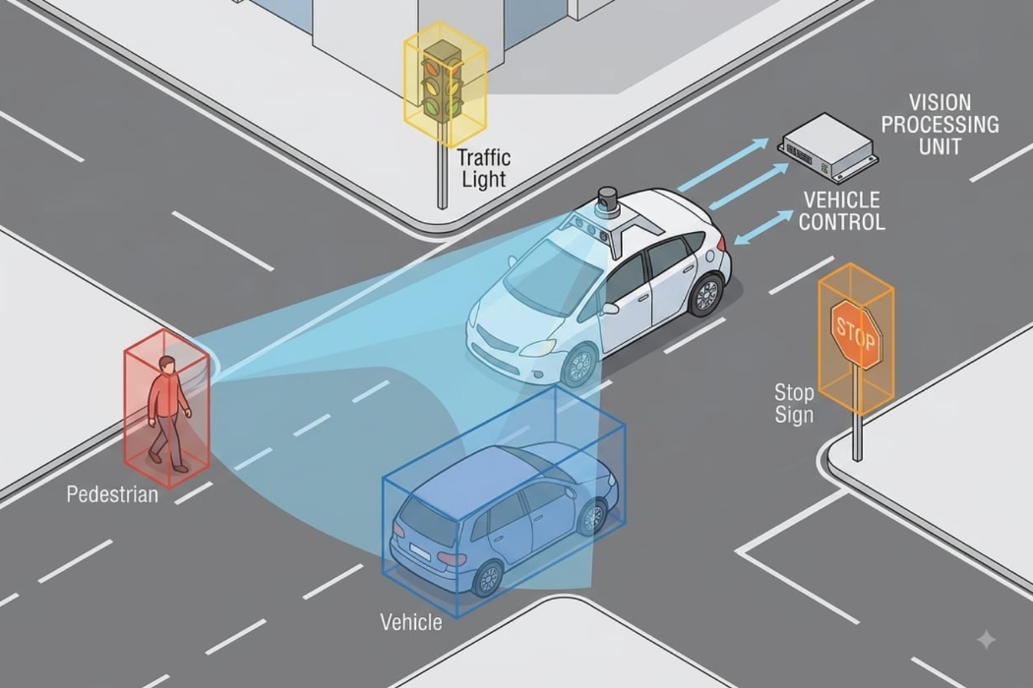

2. Smart Factory Product Inspection Selection
A manufacturing company wants to deploy a real-time computer vision system to detect defective products on a production line. The system must operate under the following conditions:
• If accuracy &lt; 95% → defects may be missed
• If processing time &gt; 50 ms → production is affected
• Hardware supports moderate computation
Methods available:
• Traditional Image Analysis: 91% accuracy, 25 ms, low computation
• YOLO: 96% accuracy, 45 ms, moderate computation
• Deep Learning: 98% accuracy, 75 ms, high computation
Task:
Compare the three methods and evaluate which method satisfies all the constraints. Justify your decision using logical reasoning based on accuracy, processing time, and computational requirements.

Method | Accuracy | Processing Time | Computation | Meets Accuracy ≥ 95%? | Meets Time ≤ 50 ms?
Traditional Image Analysis | 91% | 25 ms | Low | ❌ No | ✅ Yes
YOLO | 96% | 45 ms | Moderate | ✅ Yes | ✅ Yes
Deep Learning | 98% | 75 ms | High | ✅ Yes | ❌ No

Logical evaluation:

- Traditional Image Analysis: Processing time is good at 25 ms, but accuracy is only 91%, which is below 95%. Therefore, it fails.
- YOLO: Accuracy is 96% (≥95%), processing time is 45 ms (≤50 ms), and it requires moderate computation. Therefore, it satisfies all constraints.
- Deep Learning: Accuracy is 98%, but processing time is 75 ms, exceeding the 50 ms limit. It also requires high computation, which is beyond the supported moderate hardware.

Decision:

YOLO is the best choice because it meets the required accuracy, processing-time, and computational-resource constraints.

